
CS5003 Data Structures and Specialist Programming
Assignment no: 002
Weighting: 30% of the module mark
Deadline: 6th May 2025
Module Leader: Mona Abdelgayed Student ID: 23032697
Surgery Operations
Project Overview:
This project involved the development of a dynamic, database-driven Java web application named Surgery Operations, designed to support the day-to-day administrative functions of a surgery centre or healthcare institution. The application allows authenticated users to manage patients, doctors, surgery rooms, surgery types, and appointments efficiently through a user-friendly interface.
The system was developed following the Model-View-Controller (MVC) architecture, employing Java Servlets for the controller logic, JavaServer Pages (JSP) for the presentation layer, and MySQL as the backend database. It facilitates full CRUD (Create, Read, Update, Delete) operations across all core entities and integrates JavaScript and AJAX to enhance interactivity and data validation.
The intended users are administrative staff at medical centres or small-scale hospitals. These users may not possess technical knowledge but require a reliable interface to perform regular tasks such as booking surgeries, registering new patients, or updating medical room statuses.
Features
- Login functionality with session tracking to control access.
- Full CRUD operations for:
- Patients
- Doctors
- Surgery Types
- Surgery Rooms
- Appointments
- AJAX-based search for real-time filtering of appointments.
- JavaScript validation of form inputs (e.g., email format).
- One static page (contact.jsp) to meet coursework requirements.
- Developed using NetBeans IDE and deployed on Apache Tomcat Server.

Technologies Used
Category: Tools / Languages
Backend: Java Servlets, JDBC
Frontend: JSP, HTML5, CSS, JavaScript
Interactivity: AJAX
Database: MySQL
Architecture: MVC (Model-View-Controller)
Development: NetBeans IDE, Apache Tomcat
Note: Full implementation code (Java Servlets, JSP pages, SQL schema, and web.xml) is included in the submitted artefact zip file (StudentID_BelalUddin_Artefact.zip).
Short code excerpts are referenced in Section 5 of this report, and complete files can be found within the project’s /src and /web directories for further review.

Site Map and Navigation Structure:
The Surgery Operations Management System is designed to ensure hospital staff can easily navigate and operate it. Users can view surgery records, add new procedures, search surgeries using AJAX, and update or delete records through a simple interface. A static "Contact Us" page is also included for general correspondence. The Dashboard serves as the central hub, offering direct links to all major sections of the application.
For example, the View Surgeries page enables real-time updates and deletions, while the Search Surgeries function allows users to instantly filter results. These workflows are presented consistently to reduce user confusion and support a smooth operational experience.
The following structure outlines how pages interlink within the application:
- Home/Dashboard: Main control panel after successful login (dashboard.jsp)
- Patients Module: add_patient.jsp, view_patients.jsp, edit_patient.jsp
- Doctors Module: add_doctor.jsp, view_doctors.jsp, edit_doctor.jsp
- Surgery Types Module: add_surgery_type.jsp, view_surgery_types.jsp, edit_surgery_type.jsp
- Surgery Rooms Module: add_room.jsp, view_rooms.jsp, edit_room.jsp
- Appointments Module: schedule_appointment.jsp, view_appointments.jsp, edit_appointment.jsp
- Search Surgeries: search_appointments.jsp with AJAX integration
- Contact Us: contact.jsp – static information page
- Logout: Ends the session and redirects to login
All navigation is accessible via dashboard menu links and maintained consistently across pages for clarity and usability.

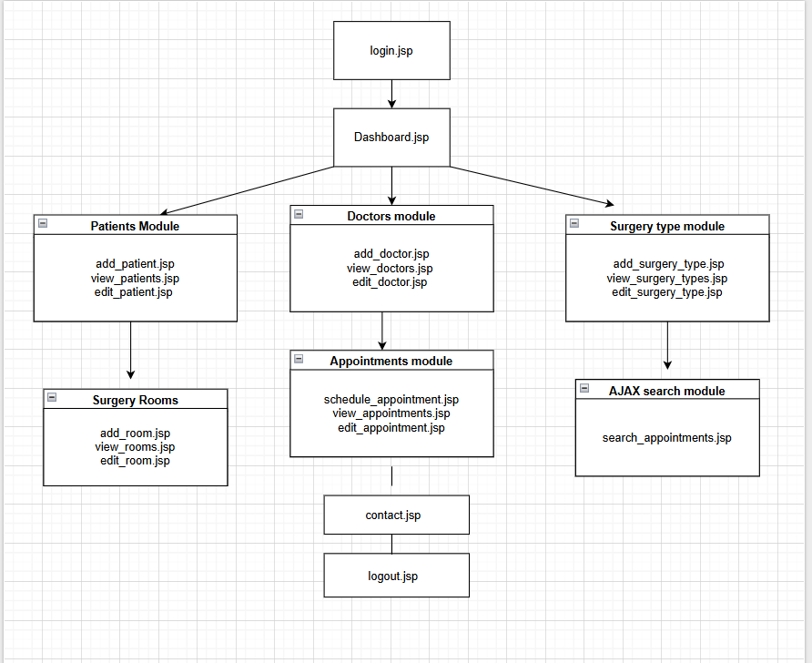

Database Design:
This application was designed with usability at the forefront to ensure a smooth user experience for administrative staff. The following five usability and interface design principles were applied throughout the system:
1. Consistency
Consistent placement of form fields, submit buttons, table layouts, and headers ensures that users can predict how to interact with different modules. All CRUD pages (e.g., add_patient.jsp, add_doctor.jsp) use a similar structure and styling, helping users learn the system quickly.

2. Structure
The application follows a clear structural layout: navigation links are grouped logically on the dashboard, and each module is accessed through distinct, labelled menu items. The form-to-table pattern (Add → View/Edit/Delete) is preserved across all modules, making workflows intuitive.

3. Error Prevention
JavaScript validation was used to prevent users from submitting incorrect data. For example, the patient registration form (add_patient.jsp) includes a script to validate the email format before submission. This prevents common form errors and saves time.

4. Visibility
All core actions (Add, View, Edit, Delete) are immediately visible and accessible. Each list view includes inline action links (e.g., “Edit” and “Delete” in view_doctors.jsp), which prevents users from navigating through unnecessary layers to complete tasks.

5. Feedback
After each user action (e.g., submitting a form or deleting a record), the user is redirected to an updated view page where they can immediately see the results of their actions. If an error occurs (e.g., database connection fails), the system redirects to an error page or logs the issue to the console for transparency.
This focus on usability ensures that non-technical users can navigate the platform efficiently and with minimal training.
Database Tables and Entity Relationship Diagram (ERD)
The database for the Surgery Operations application was designed to support modular, efficient data access for all core components of the system. The schema includes six core tables, with relationships mapped via foreign keys to maintain referential integrity. The structure reflects real-world surgery centre workflows, such as linking patients to doctors and appointments.
The database was implemented using MySQL, and all data interactions are handled using JDBC within the Java Servlets.

Core Tables and Purpose
- patients – Stores patient personal and contact details.
- doctors – Contains doctors’ full names and specialties.
- surgery_types – Defines available surgical procedures with descriptions and duration.
- surgery_rooms – Lists surgery rooms along with capacity and availability status.
- appointments – Links patients, doctors, surgery types, and rooms to scheduled procedures.
- users – Stores login credentials and user roles for authentication.

Field Types Used
All tables incorporate a range of data types including:
- INT – for IDs, capacity
- VARCHAR – for names, descriptions, contact info
- BOOLEAN – for room availability
- DATE and TIME – for appointment scheduling
This meets the coursework requirement to use at least three field types.

Entity Relationships
The database schema implements the following one-to-many relationships:
- One patient can have many appointments
- One doctor can be scheduled for many appointments
- One surgery type can appear in many appointments
- One room can host multiple appointments
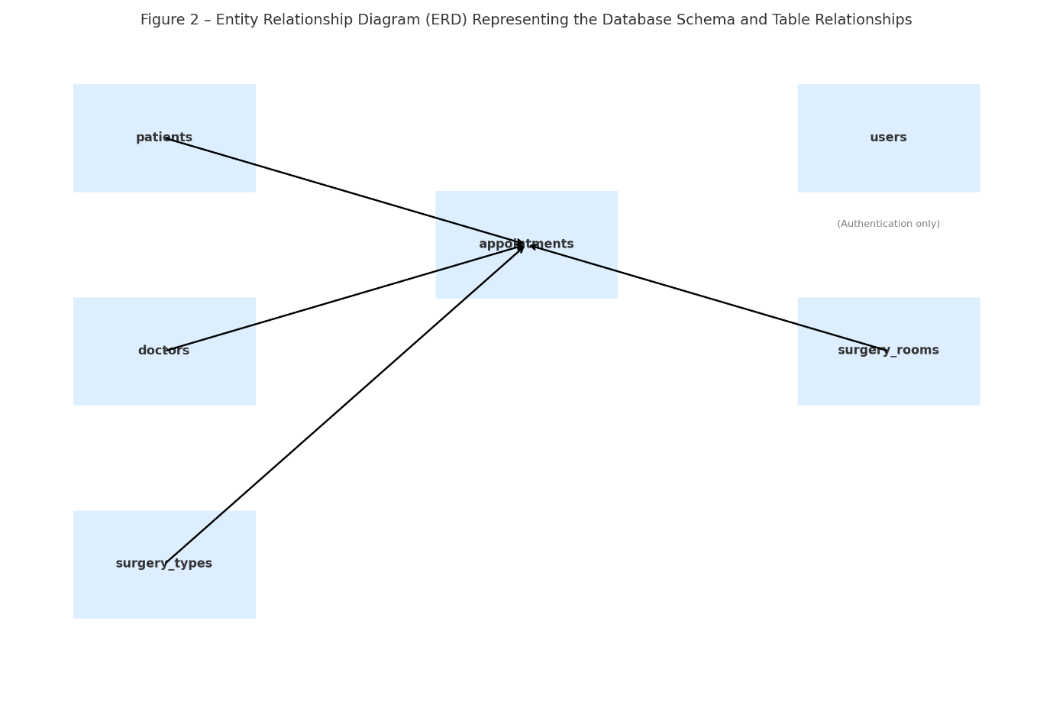
- The appointments table serves as a central junction table referencing all others

Code Architecture and Technologies Used
This application was developed using the Model-View-Controller (MVC) architecture. The system separates concerns between:
- Model: MySQL database accessed via JDBC
- View: JSP pages rendering dynamic HTML forms and tables
- Controller: Java Servlets handling logic and database interaction
Each module (Patients, Doctors, Appointments, etc.) follows this structure, resulting in a scalable and maintainable design.

Java Servlets (Controllers)
Each entity in the system is managed through a set of Java Servlets that handle CRUD operations. For example:
- AddPatientServlet.java – handles new patient insertion
- EditDoctorServlet.java – updates doctor data
- DeleteRoomServlet.java – deletes a surgery room
- ScheduleAppointmentServlet.java – inserts a new appointment
- LoginServlet.java – handles authentication and session tracking
These servlets read form inputs, perform validation or conversion (e.g., parsing dates), and interact with the database via JDBC.

JSP Pages (Views)
The interface is built using JavaServer Pages (JSP). Each page includes:
- HTML/CSS for layout
- Embedded Java (<% ... %>) for dynamic content rendering
- Form submission using POST method to a corresponding servlet
Examples include:
- add_patient.jsp, view_appointments.jsp, edit_doctor.jsp, etc.

JavaScript Integration
The project uses client-side JavaScript for real-time validation and improved user experience. For example, the add_patient.jsp page includes the following script to validate email format before submission:
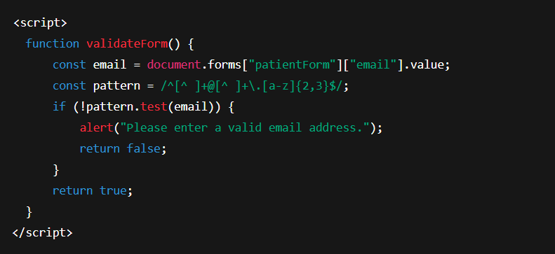
This ensures basic input validation happens before the form is processed by the server.
AJAX Integration
An AJAX-based live search is implemented in search_appointments.jsp. As the user types a name, the front-end sends a request to SearchAppointmentServlet.java to fetch results without refreshing the page.
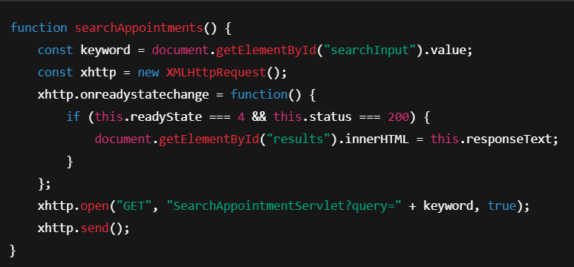
This improves interactivity and user responsiveness.

CSS Styling
The application uses a non-trivial CSS script to style form inputs, tables, and navigation:
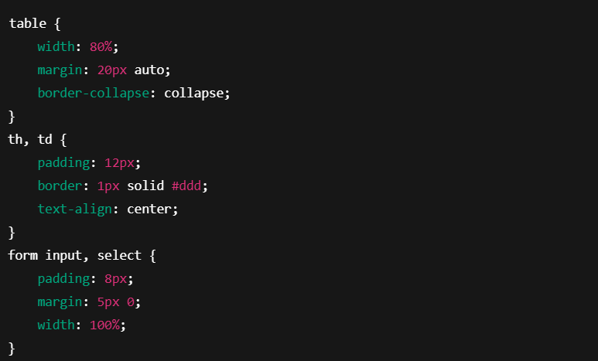
CSS ensures consistent form presentation, spacing, and readability throughout the site.
Code file:
The application is fully configured to run in NetBeans IDE with Apache Tomcat.

The development of the Surgery Operations Management System has been an insightful and rewarding process that significantly enhanced my understanding of full-stack web application development using Java EE technologies. This coursework provided me with practical experience in implementing a complete web system that connects dynamic JSP pages with backend Java Servlets and a MySQL relational database, while also incorporating client-side validation and AJAX-based interactivity.
The project was built using NetBeans IDE 18 and deployed locally using Apache Tomcat 9.x. The backend database was implemented in MySQL, with data access handled via JDBC. The technologies used throughout the development include Java, JSP, Servlets, HTML, CSS, JavaScript, and SQL.
This environment allowed for an organized, modular structure using the MVC (Model-View-Controller) architecture, with Servlets handling business logic, JSPs for the presentation layer, and MySQL serving as the persistent data store. The tools provided a seamless workflow for writing, testing, and deploying the application.

